Project update-1
Date: 5th June 2026

Github repo link: https://github.com/Vaibhavkrishna2001/Financial-Time-Series-Analytics
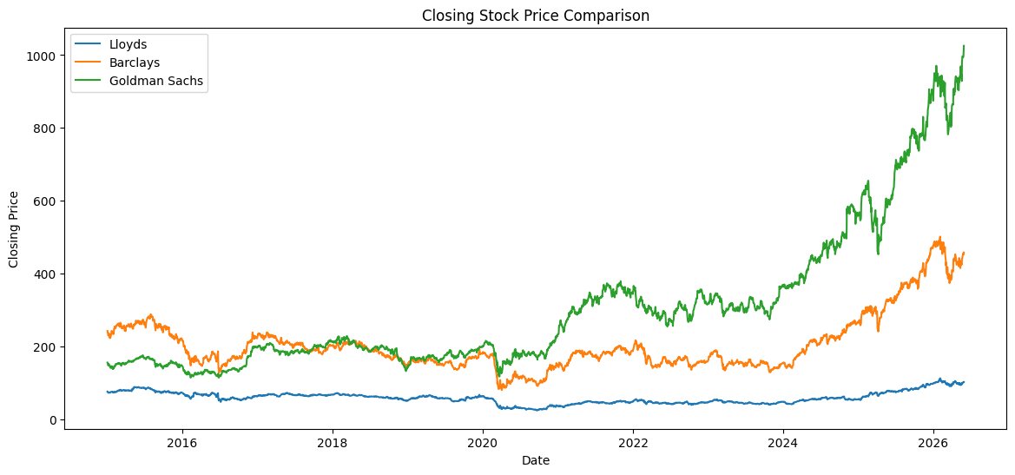
What the graph shows
This graph shows the closing stock prices of Lloyds, Barclays, and Goldman Sachs from 2015 to 2026.
Key observations:

Goldman Sachs
- Shows the strongest long-term growth.
- Its price went up from roughly 150 in 2015 to more than 1000 by 2026.
- It had a big increase after 2020.
- This shows good market performance and strong investor confidence.
Barclays
- Begun around 240 in 2015.
- It saw drops during 2020.
- It bounced back strongly after 2023.
- By 2026, it had reached about 450 to 500.

Lloyds
- Had the lowest stock prices throughout the period.
- It dropped a lot during 2020.
- It slowly recovered after 2023.
- Its growth was much slower compared to Goldman Sachs and Barclays.

Interpretation:
The analysis of closing stock prices shows that Goldman Sachs had the strongest long-term growth among the three banks.
Even though all three faced market challenges around 2020, Goldman Sachs showed the most significant recovery and continued to rise steadily. Lloyds had the lowest stock prices and the slowest growth during the time period observed.

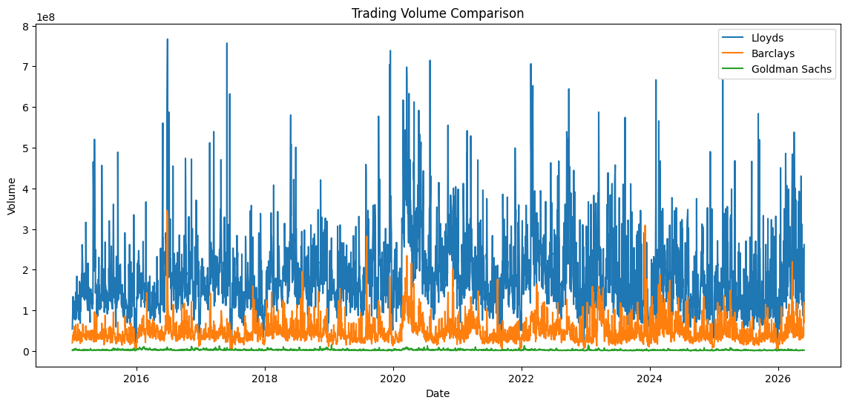
What the graph shows
This graph shows how active investors are by looking at how many shares are traded each day.
Key observations
Lloyds:
- Lloyds has the most trades every day.
- There are several big jumps where more than 700 million shares were traded.
- This shows a lot of people are buying and selling, and there's plenty of liquid market.
Barclays
- Barclays has a steady but not very high level of trading.
- It's less than Lloyds but more than Goldman Sachs.
Goldman Sachs
- Goldman Sachs has the least trading activity.
- Its trading pattern is more consistent.
- Even though it's not traded as much, its stock price went up a lot.
Important Insight
Just because a company has a lot of trades doesn't mean its stock will grow more.
For example:
- Lloyds has the most trades.
- Goldman Sachs has the biggest price rise.

Interpretation:
Throughout the study period, Lloyds Banking Group had the most trading activity, showing strong market liquidity and investor interest.
Goldman Sachs had less trading, but its stock price increased more, showing that high trading volume isn't always linked to better stock performance.

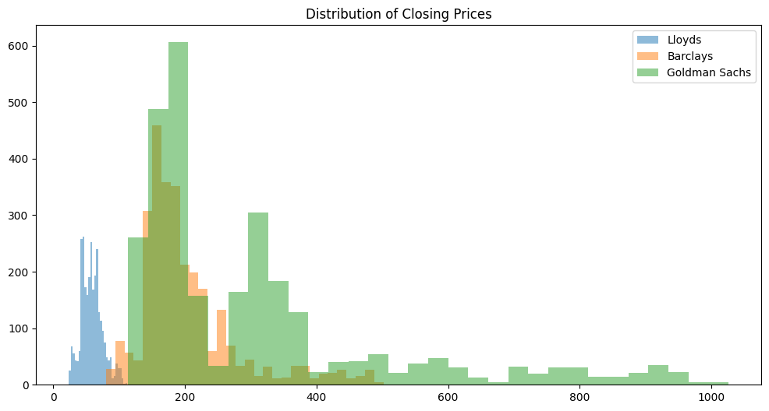

What the graph shows
This histogram shows how stock prices changed over time.
Key observations:
Lloyds
- The prices are mostly between about 40 and 100.
- The spread is narrow.
- This suggests the stock prices stayed relatively steady.
Barclays
- The prices are mostly between about 140 and 250.
- The spread is moderate.
- This indicates the stock prices had some ups and downs but not extreme.
Goldman Sachs
- The prices spread out a lot.
- They range from about 140 to over 1000.
- This shows the stock had big growth and large price changes over time.
Interpretation
Goldman Sachs has the widest range of closing prices, showing big growth and price changes during the time period.
Lloyds has a much narrower range, indicating more stable but lower stock performance.

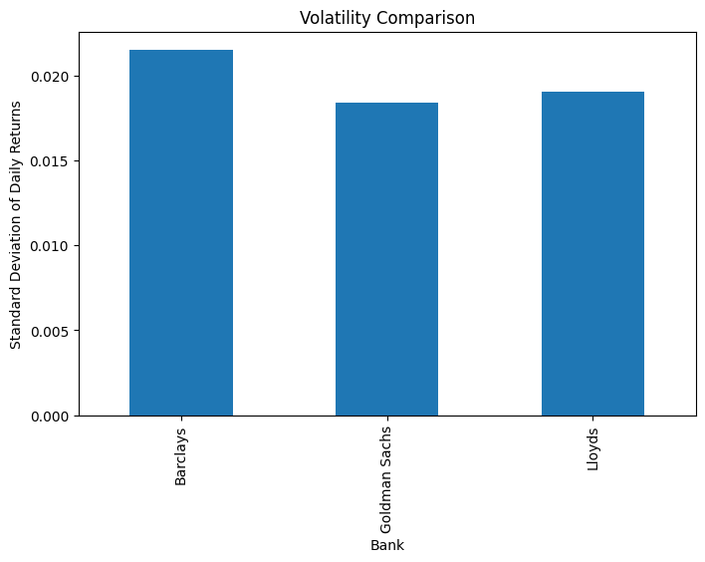
What the graph shows
Volatility was measured by looking at the standard deviation of daily returns.
Higher numbers mean bigger daily price changes.
Results
Bank Approximate | Volatility
Barclays | 0.0215
Lloyds | 0.0190
Goldman Sachs | 0.0184

Key observations:
Barclays
- Highest volatility.
- Most affected by market changes.
- Higher risk for short-term investments.
Lloyds
- Moderate volatility.
- More stable than Barclays.

Goldman Sachs
- Lowest volatility.
- Surprisingly steady, even though it had strong growth.

Most Important Finding
Goldman Sachs achieved:
- Highest long-term growth
- Lowest volatility
- This mix shows strong and steady market performance.
Interpretation:
Looking at volatility, Barclays was the most unpredictable, with the highest standard deviation in daily returns.
Goldman Sachs had the least volatility, even though it showed the strongest growth over time, which means it performed more steadily during the study period.

